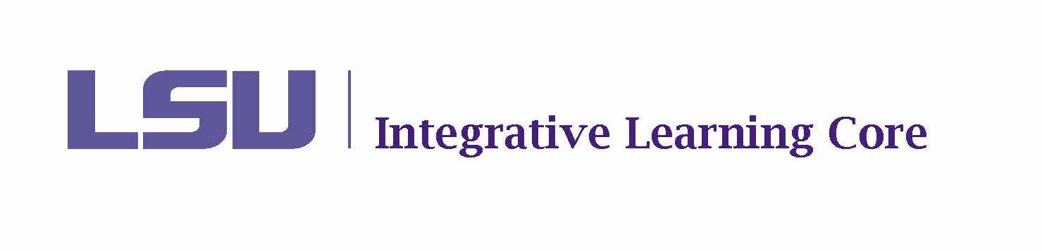

ILC COURSE PROPOSAL MODIFICATION FORM
Reviewed DATE ~ Committee Recommendation

Course Information
Designation
Number
Title
BOR and Proficiency
Modification 1:

Course Coordinator Response:

Modification 2:

Course Coordinator Response:

Modification 3:
Course Coordinator Response:

