TABLE OF CONTENTS

Section One: Welcome 2
Degree Programs & Minors Offered 3
College of Engineering Contacts 4
Student Services & Diversity Initiatives 5-6
Additional Campus Services 7

Section Two: Getting Started 8
Tiger Talk 9

Section Three: Managing Degree Requirements 10
Arts/Humanities/Social Sciences/Life Sciences General Ed. Electives 10
Math and Physics Sequences 11
Flow Chart 12
Degree Audit 13-14
Academic Information and Requirements 15-16

Section Four: Additional Resources 16
Hands-On Experience 17
Helpful Tips 18
Student Organizations 19

Section Five: After Orientation 20

WELCOME
Welcome to the LSU College of Engineering, Louisiana’s flagship engineering program and one of the top-five fastest growing engineering colleges in the United States. As a student in the College of Engineering (CoE), you will encounter challenging academics, become globally aware, gain an entrepreneurial spirit, and develop strong communication skills. Upon successful completion of a degree in one of the engineering disciplines, computer science, or construction management, you will be prepared to address societal problems and improve others’ quality of life.
Engineers research, develop, design, build, operate, and manage the systems and devices that drive our society, working to make them as efficient and effective as possible. Computer scientists address scientific problems through the design of software and hardware, guiding the computational foundation for personal, commercial and governmental use. Construction managers oversee commercial, residential, and public construction projects of varying size and complexity.
What follows in this, Guide to Success in the LSU CoE, will assist you as you schedule your first courses, plan for future semesters, seek answers to questions about academic policies, find additional LSU resources, and look for extracurricular opportunities for engagement. There are also CoE and LSU contacts you will find helpful. Congratulations on beginning your journey to become an LSU engineer, computer scientist, or construction manager!

Degree Programs Offered
Major | Abbreviation | Department/School | Department Abbreviation
Biological Engineering | BE | Biological & Agricultural Engineering | BAE
Chemical Engineering | ChE | Cain Department of Chemical Engineering | ChE
Civil Engineering | CE | Civil & Environmental Engineering | CEE
Computer Engineering | EEC | School of Electrical Engineering & Computer Science | EECS
Computer Science | CSC | School of Electrical Engineering & Computer Science | EECS
Construction Management | CM | Bert S. Turner Department of Construction Management | CM
Electrical Engineering | EE | School of Electrical Engineering & Computer Science | EECS
Environmental Engineering | EVEG | Civil & Environmental Engineering | CEE
Industrial Engineering | IE | Mechanical & Industrial Engineering | MIE
Mechanical Engineering | ME | Mechanical & Industrial Engineering | MIE
Petroleum Engineering | PETE | Craft & Hawkins Department of Petroleum Engineering | PETE

Minors Offered
Minor | Abbreviation | Department/School
Digital Media AVATAR Technology | DMTEC | College-wide
Robotics Engineering | ROBOT | College-wide
Technical Sales | TECHS | College-wide
Biological Engineering | BE | BAE
Sugar Engineering | SGENG | BAE
Environmental Engineering | EVEG | CEE
Structural Engineering | STENG | CEE
Surveying | SURV | CEE
Transportation Engineering | TENGR | CEE
Construction Management | CM | CM
Computer Science | CSC | EECS
Electrical & Computer Engineering | ECE | EECS
Aerospace Engineering | AERO | MIE
E-Commerce | ECOM | MIE
International Automotive Engineering | IAE | MIE with Univ. Torino (Requires Study Abroad)
Materials Science & Engineering | MATSC | MIE
Mechanical Engineering | ME | MIE
Nuclear Power Engineering | NCPE | MIE

COLLEGE OF ENGINEERING CONTACTS
Judy Wornat | Dean | 2214 Patrick Taylor | 225-578-3153
Craig Harvey | Associate Dean | 2225 Patrick Taylor | 225-578-8761

ENGINEERING DEPARTMENTS & CHAIRS
Department | Location | Dept. Phone# | Chair/Head
BAE | 149 E. B. Doran | 225-578-3153 | David Constant
CEE | 3255C Patrick Taylor | 578-8442 | George Voyiadjis
ChE | 3307 Patrick Taylor | 578-1426 | John Flake
CM | 3319 Patrick Taylor | 578-5112 | Charles Berryman
CSC | 3325E Patrick Taylor | 578-1495 | Bijaya Karki
EE & EEC | 3325D Patrick Taylor | 578-5241 | Jerry Trahan
MIE | 3261E Patrick Taylor | 578-5804 | Dimitris Nikitopoulos
PETE | 3207C Patrick Taylor | 578-5215 | Karsten Thompson

UNDERGRADUATE COORDINATORS
Curriculum/Advisor | E-mail | Location | Phone #
BE/Nicholas Totaro | ntotar1@lsu.edu | 105 E. B. Doran | 225-578-1083
CE/Suresh Moorthy | moorthy@lsu.edu | 3255E Patrick Taylor | 578-4846
ChE/Barry Guillory  Kerry Dooley (Transfer/Re-entry) | barryguillory@lsu.edu  dooley@lsu.edu | 3308A Patrick Taylor  3315Q Patrick Taylor | 578-2173  578-3063
CM/Stephanie Heumann | sheumann@lsu.edu | 3319 Patrick Taylor | 578-8856
CSC/Patti Aymond  Jian Zhang (Transfer/Re-entry) | paymond@lsu.edu  zhang@csc.lsu.edu | 3270A Patrick Taylor  3272K Patrick Taylor | 578-4359  578-8353
EE & EEC/John Scalzo | jscalz1@lsu.edu | 3335 Patrick Taylor | 578-5478
EVEG/John Pardue | jpardue@lsu.edu | 3240T Patrick Taylor | 578-8661
IE/Isabelina Nahmens | nahmens@lsu.edu | 3261C Patrick Taylor | 578-0943
ME/Warren Waggenspack | mewagg@lsu.edu | 3261D Patrick Taylor | 578-5907
PETE/Fred Thurber  Richard Hughes (seniors) | fthurbe@lsu.edu  rghughes@lsu.edu | 3207D Patrick Taylor  3212C Patrick Taylor | 578-6058  578-6038

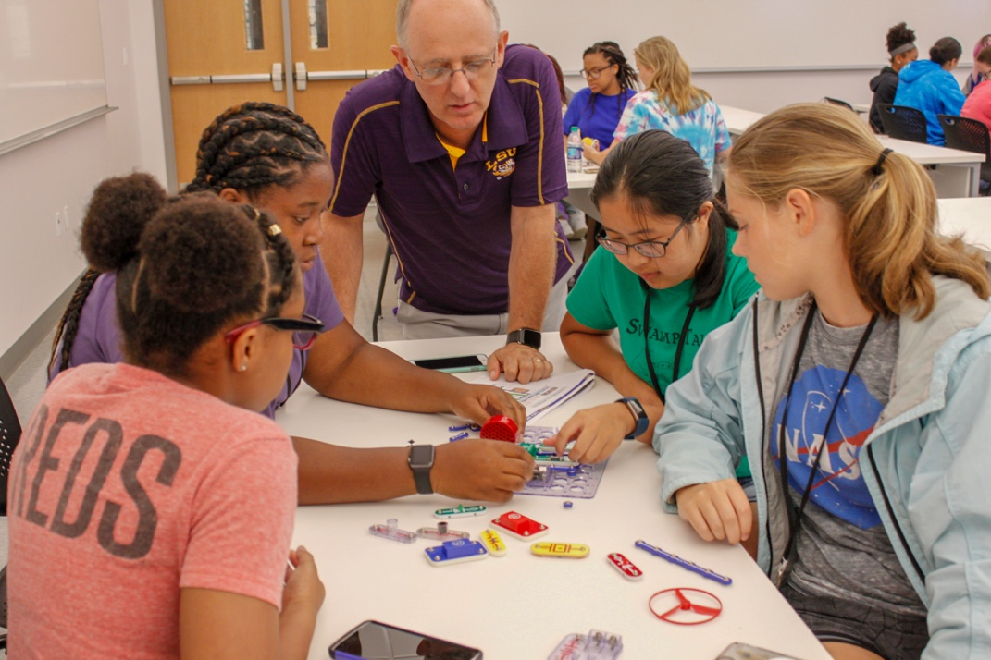

STUDENT SERVICES & DIVERSITY INITIATIVES
Student Services and Diversity Initiatives in the College of Engineering is a team of professionals who collectively assist students from their initial contact with LSU and the college all the way to their graduation. These units provide students with academic support and educational resources that enhance their experience, as well as opportunities for engagement through various camps, student organizations, peer mentoring, diversity/engineering ambassadors, and undergraduate research.

COUNSELING & ADVISING
2228 Patrick Taylor, William Brookshire Student Services Suite (225-578-5731)
Barbara Reonas |  | Assistant Dean |  | breonas@lsu.edu
Vicki Hannan |  | Office Manager |  | eghann@eng.lsu.edu
Kyle Lavergne |  | Coordinator |  | klavergne@lsu.edu
Anissa Addison-Guerin |  | Counselor |  | aaddis7@lsu.edu
Lisa B. Fontenot |  | Counselor |  | lisaf@eng.lsu.edu
Ashleigh Turner |  | Counselor |  | aturner1@lsu.edu
Bianca Lee |  | Counselor |  | blee37@lsu.edu
Ashley Gray |  | Counselor |  | ashleygray@lsu.edu
Arlyn Saucier |  | ERC Coordinator |  | arlyn@lsu.edu
Courtney Frost |  | Engineering Career Coach |  | cfrost6@lsu.edu

- Serve as a first contact for those needing assistance.
- Provide academic, career, and personal counseling.
- Give general advice on how to solve various student problems.
- Refer students to best source of information (ex: Career Center, Computer Rooms, etc.).
- Assist students with registration and schedule changes/issues and exam rescheduling.
- Supply students with unofficial transcripts, degree audits, and rank in class.
- Assist student organizations in obtaining conference rooms for meetings.
- Program minors for students wishing to add them.

DIVERSITY INITIATIVES
2228 Patrick F. Taylor Hall
Sarah Jones | Associate Director | sjones@lsu.edu |  | 578-5705

- Develop a pipeline of diverse talent in engineering, construction management, and computer science.
- Offer student seminars for professional development, career, and academic success.
- Advise student leaders for Diversity Ambassadors, SWE, NSBE, and SHPE.
- Facilitate signature events including WISE, First Impressions, and Engineering Tiger Connections (Bengal Bound).
- Offer ENGR 1050: Intro to Engineering, a communication intensive course to explore the CoE disciplines.

CHEVRON CENTER FOR ENGINEERING EDUCATION
1269 Patrick F. Taylor Hall
Elizabeth Melvin | Director | lizmelvin@lsu.edu | 225-578-3072
Adrienne Steele | Assistant Director | alopez@lsu.edu | 578-5349
David “Boz” Bowles | Coordinator | dbowles@lsu.edu | 578-9952
Paige Davis | Instructor | pdavis3@lsu.edu | 578-8658

- Offer expert advice on communication projects (written, oral or technological).
- Facilitate access to computer workstations, high-tech A/V applications, 3-D scanners, and printers.
- Direct the Engineering Communication Studio-a place for teamwork.
- Provide opportunities for global engineering education experiences.
- Develop a support system of students, faculty, and staff that increases student confidence, provides mentoring, develops teamwork, and leadership skills.
- Facilitate Encounter Engineering (E²) Camp for 1st time freshmen.
- Provide supplemental instruction for several 1st & 2nd year foundational courses.
- Advise the Society of Peer Mentors, outreach to local schools for regional/national robotics competitions.
- Offer Supplemental Instruction (SI), providing peer-facilitated sessions for students enrolled in large, historically difficult, engineering and computer science courses.

Additional Campus Services
ADD/DROP/RESIGN | Academic Counselor | Center for Freshman Year/  Senior College
ADMISSIONS | Office of Admissions | 1146 Pleasant Hall | 225-578-1175
CAMPUS/STUDENT JOB | LSU Olinde Career Center | 158 LSU Student Union | 578-2162
CAMPUS TRANSIT | Parking & Transportation | Public Safety Building | 578-5555
CAREER SERVICES | LSU Olinde Career Center | 158 LSU Student Union | 578-2162
CORRESPONDANCE COURSES | Independent Study Office | 1225 Pleasant Hall | 578-2500
DISABILITIES RESOURCES | Disability Services | 115 Johnston Hall | 578-5919
FEES | Office of University Registrar | 112 Thomas Boyd | 578-1686
FINANCIAL AID | Financial Aid & Scholarships | 1146 Pleasant Hall | 578-3103
HONORS | Honors College | French House | 578-8831
INTERNATIONAL STUDENTS | International Services Office | 101 Hatcher Hall | 578-3191
MEDICAL/MENTAL HEALTH SERVICES | Student Health Center | Corner of Infirmary Rd & West Chimes St | 578-6271
MULTICULTURAL AFFAIRS | Office of Multicultural Affairs | 335 LSU Union | 578-4339
PRE-MED INFORMATION | Nicholas Totaro | 105 E.B. Doran | 578-1056
SCHOLARSHIPS | Financial Aid & Scholarships Engineering | 1146 Pleasant Hall 2228S Patrick Taylor | 578-3103 578-8408
TIGER TRAILS | Parking & Transportation  Available via mobile app | Public Safety Building | 578-5000
TRANSCRIPTS (OFFICIAL) | Office of University Registrar Or Request via myLSU | 112 Thomas Boyd | 578-1686
TRANSFER CREDIT | Office of Admissions  Counseling & Advising | 1146 Pleasant Hall 2228 Patrick Taylor | 578-1175 578-5731
TUTORING & STUDY SKILLS | Center for Academic Success | B-31 Coates Hall | 578-2872

GETTING STARTED
Admission Requirements for the College of Engineering
LSU freshmen are first admitted into the University Center for Freshmen Year (UCFY). Transfers may be admitted, depending on credit hours and GPA, either into the University Center for Advising and Counseling (UCAC) or directly into the College of Engineering. The requirements for CoE admission are as follows:
- 24 earned credit hours and completion of MATH 1550 with a “C” grade or better.
- A 2.0 GPA on all LSU work, and for PETE majors a 2.8 GPA on all courses applying to the degree.
- For transfer students, a cumulative GPA of 2.5 (and the above requirements).
Scholarships
As you complete semesters, gain work experience, and update your resume, take the opportunity to revise your myLSU scholarship application online. This will ensure you receive consideration for all scholarships available.
- Look on your myLSU desktop under Financial Services Section and select Update Scholarship.
- Be prepared, as you may be notified by email to provide supporting documents for specific scholarship consideration, e.g. résumé, personal, and/or financial need statements as well as part-time work verification.
- For a list of FAQs on the engineering scholarships, see:
https://scholarshipfaq.eng.lsu.edu/
Faculty Advisors
Each department in the College of Engineering has assigned faculty members who provide the following services:
- Assist students in preparing schedules for future semesters.
- Explain course and curricula requirements.
- Discuss course prerequisites and proficiency requirements.
- Ensure that students meet accreditation standards.
- Offer career information about various fields.
- Lift advising flags for all students in the College.
- Refer student to ENGR Counseling & Advising for general questions.
**Contact your department to find out which faculty advisor to whom you are assigned.
ENGR Weekly
ENGR Weekly is an email of highlights and links to information about events in the College of Engineering. The email is sent on Thursday afternoons. Students are encouraged to submit their events, meetings, and other announcements for inclusion in ENGR Weekly. Patrick F. Taylor Hall renovation updates will be communicated through ENGR Weekly.
LSU Mobile
LSU Mobile is the official mobile application suite of Louisiana State University. It allows students to connect to resources on-the-go. The suite is available for iPhone, iPod Touch, and Android devices. A mobile website is available for other devices. Check it out at https://as.lsu.edu/lsumobile.
Follow CoE on: Facebook, Instagram, LinkedIn, RSS Feed, Twitter, & YouTube
TIGER TALK
ALEKS – “ALEKS Calculus Placement Test” required for registration in Math 1550 or 1551.
CATS – The Comprehensive Academic Tracking System designed to help students reach academic success at LSU and make sure that they are progressing toward graduation each semester. Each major has a RECOMMENDED PATH that is the optimal path for graduation. CATS checks students’ progress each semester by tracking them on the CRITICAL REQUIREMENTS needed and gives feedback when students are not meeting those requirements. For more information, go to: http://sites01.lsu.edu/wp/registraroffice/academics/cats/.
COMPUTER LABS – The Chevron Center (1269 Patrick Taylor Hall) offers computers for student-use Monday through Thursday: 8:30 a.m. to 10 p.m. and Friday: 8:30 a.m. to 4:30 p.m.
CO-OP – Cooperative Education is a work/school rotation program, allowing students to gain valuable experience in their intended field. Work and school are generally alternated until two or three semesters of work are completed. Register with the LSU Olinde Career Center by attending a Career Workshop.
CROSS REGISTRATION – Southern University and Baton Rouge Community College offer a list of classes available for easy credit transfer to LSU.
DEAN’S APPROVAL – Students seeking “dean’s approval” or “college approval” on various forms should begin with Counseling & Advising. In most cases, a counselor or the assistant dean or associate dean is authorized to sign for the dean.
DEGREE AUDIT – A degree audit lists all classes required in your major. It indicates which classes have been completed and which classes are still required. Print a copy from your myLSU account and take it with you whenever you go to see an advisor or counselor.
FLOWCHARTS – A complete list of class requirements, by major, detailing the recommended sequence of class scheduling in order to graduate in four years.
INTERNSHIPS – A one-semester work program coordinated by the LSU Olinde Career Center. Register with the Career Center by attending a Career Workshop as soon as possible. Dates are listed on the Career Center website, www.lsu.edu/career.
myLSU – Provides e-mail service, access to degree audits, request transcripts, declare a graduation date, mid-term grades, and final grades. It also offers on-line class availability, registration, and access to departmental information, such as class notes and past tests. How to login?
REVEILLE – LSU’s student newspaper provides campus and local news, sports and editorials as well as listings of campus activities. It is available in the lobby of Patrick F. Taylor Hall and around campus.
TIGERWARE –A website that contains free software downloads for LSU Students, Faculty, and Staff. The software distribution service, called TigerWare, provides numerous Microsoft products available to download to Windows and Macintosh computers. TigerWare may be accessed at http://tigerware.lsu.edu/.
TIGERBYTES II –TigerBytes is a personal file storage application funded by the Student Technology Fee and the Office of Computing Services. TigerBytes allows students, faculty, and staff to store and access their files from many computer labs on campus and through the web via their myLSU account. Each undergraduate and graduate student who is currently enrolled has 50 megabytes available to them through an H: or Home drive when they log on to a computer running Windows in one of the public labs at LSU. In addition, TigerBytes can be accessed through myLSU.
MANAGING DEGREE REQUIREMENTS
Arts/Humanities/Social Sciences/Life Sciences General Education Requirements
The General Education list is catalog specific (catalog of record). This means that the catalog you follow for your curriculum requirements lists your eligible ARTS/HUMANITIES/SOCIAL SCIENCES/LIFE SCIENCES electives. While the College of Engineering prescribes your general education math and physical science courses, you have some flexibility when scheduling general education electives. Be sure to consult your flowchart, catalog, and degree audit to ensure you are taking courses that apply to your degree program.
ARTS: (3 hours)
All Majors: Any one, approved course
HUMANITIES: (9 hours)
1. CM & IE Majors: Communication Studies 1061 or 2060 and two additional courses
2. CSC Majors: Communication Studies 1061, 2040, 2060, or 2063, and one English or Honors Humanities course, and one additional course
3. EE & EEC Majors: PHIL 2018 or 2020 and two additional courses
4. ME Majors: PHIL 2018, 2020, or 2050 and CMST 1061, 2060, 2063, or a foreign language, and one additional Humanities course
5. All Other Majors: Any three courses
SOCIAL SCIENCES: (6 hours)
1. CSC, EE and EEC Majors: Two courses (one course must be at 2000 level or above)
2. BE Majors: AGEC 2003 or ECON 2030 and one additional Social Science course
3. ME Majors: ECON 2030 and INTL 2000 or HNRS 2020
4. CHE, CE, CM, EVEG, IE, and PETE Majors:
Econ 2030 and one additional course -OR- Econ 2000 and Econ 2010
IE majors must also meet the Global Knowledge Requirement through the Arts, Humanities, or Social Sciences.
LIFE SCIENCES: (3 hours)
1. BE, CHE, and EVEG Majors: Biol 1201
2. IE Majors: Biol 1001 or 1201
3. CM Majors: ENVS 1126
4. CE, EE, EEC, ME, and PETE Majors: Choose one course listed under Natural Science and denoted with an asterisk (*)
5. CSC Majors: May choose either BIOL1001 or 1201
*CSC majors must also meet an additional laboratory requirement and complete either a biological or physical science sequence. Students should see the catalog for more information.

REGISTRATION IN MATH 1550/1551
MATH1550 (Calculus I) is the first required math course that applies to degree programs within the College of Engineering; however, students may need to take MATH 1021, 1022, or 1023 to be prepared. The ONLY prerequisite for MATH 1550 is a current ALEKS score of 70% and 75% for MATH 1551 (Honors Calculus I). A current ALEKS score is one earned within six months of the first day of the semester you begin either MATH1550 or MATH1551.
Engineering & Computer Science Math Sequence
Construction Management Math Sequence
REGISTRATION IN PHYSICs
There are different physics sequences for the various engineering and construction management programs. CSC students may use either physics sequence (or other physical science sequence) to meet their science requirements.
Engineering Physics Sequence*
2nd PHYS for CE, EVEG, IE & PETE
1st PHYS for ALL ENGR Majors
2nd PHYS for BE, CHE, EE, EEC & ME
3rd PHYS for PETE
Construction Management Physics Sequence
DEPARTMENTAL FLOWCHARTS
- Flowcharts depict all required courses for a degree program by recommended semester of enrollment.
- Flowcharts illustrate prerequisites and co-requisites, and they are a great tool when planning course schedules for future semesters.
- Flowcharts are available for each curriculum, by catalog year in your department, in Engineering Counseling & Advising (Audubon Sugar), or online at:
http://www.lsu.edu/eng/current/resources/flowcharts.php
How to Read a flowchart

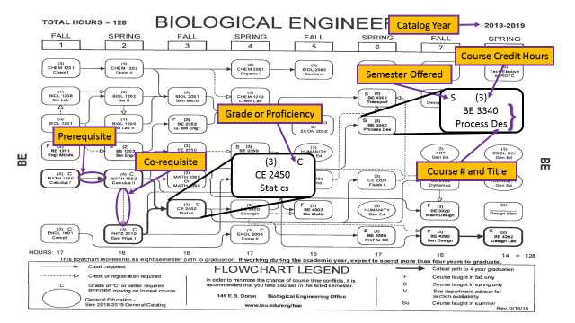
THE DEGREE AUDIT
Q: What is a degree audit?
A: The degree audit is a document that lists requirements needed to complete a particular degree program. In addition, this document matches the courses from your transcript to those requirements and displays completed courses, courses in progress, courses taken but not applied to the degree, and courses needed for degree completion. The degree audit serves as an advising tool, but it also serves as the document to verify that you have met your graduation requirements (graduation checkout document).
Q: What is the difference between the degree audit on myLSU and the one you can get from Counseling & Advising?
A: The format is different. The one from Counseling & Advising will be easier to follow.
Q: Where can I get one?
A: A copy of your degree audit is available through myLSU, your department, or in Counseling & Advising.
Q: How often should I review my degree audit?
A: You are encouraged to go over a new degree audit with your faculty advisor each semester prior to registration. Also, we advise you to review your degree audit before the start of each semester specifically to check the “Courses Not Applied To Major Degree Program.”
Q: How do I read it?
A: The symbols on the degree audit indicate your status in regard to completing a particular requirement. The symbols are explained as follows:
OK = a requirement has been met.
IP = course work within a requirement is in progress.
NO = a requirement has not been met and is not in progress.
+ = a sub-requirement within a requirement has been met.
# = a sub-requirement within a requirement is in progress.
- = a sub-requirement within a requirement has not been met.

Q: What if I find a mistake?
A: Should you find a problem with your degree audit, see a counselor in Counseling & Advising. Always check the Courses Not Applied to Major Degree Program section of your degree audit to ensure that all completed and currently enrolled courses are counting toward your degree. If a substitution is necessary, see your advisor to initiate a petition and bring it to Counseling & Advising.

How to Read a Degree Audit
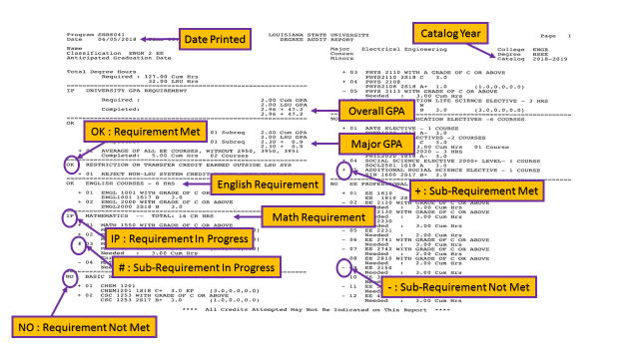

ACADEMIC INFORMATION AND REQUIREMENTS
Grade Point Average in Major Department
In order to graduate, each student must have at least a 2.0 GPA in the major department. This includes only courses with the appropriate departmental prefix (i.e., industrial engineering, mechanical engineering, etc.) for which a grade, A-F, was earned. It is suggested that you continually monitor your major department GPA that is found in the second requirement on page one of the degree audit.
Note: Only courses in which a grade of “D” or “F” was earned may be repeated. In addition, students within 24 hours of graduation cannot duplicate sophomore level courses in the major field.
College of Engineering Residency Requirement
In order to obtain a degree from the College of Engineering, each student must meet the following minimum residency requirement:
- Complete at least 30 hours of course work while enrolled in the major department in which the degree is to be received.
- Within this 30 hours of course work, the following conditions must be met:
  - 15 hours of required engineering, CM or CSC courses or approved technical electives at the 3000 level or above.
    - 9 of these 15 hours must be at the 4000 level in the major department.
  - All courses in residence must be approved by the department chair.
College Proficiency Requirements
ENGLISH: A grade of “C” or better must be earned in all required English courses in the student’s curriculum.
MATH: A grade of “C” or better must be earned in MATH 1550 and 1552 for Engineering and Computer Science majors. Construction Management students must earn a “C” or better in MATH 1550.
PHYSICS: Engineering students must earn a grade of “C” or better in PHYS 2110. Construction management students must earn a grade of “C” or better in PHYS 2001 and 2002. See the LSU General Catalog for prerequisites and co-requisites for these courses.
If you do not make at least a C grade in any of these courses, you MUST repeat the course before moving on to the next course.
NOTE: Individual departments may have additional requirements. See the catalog for details.

Incomplete Grades
After the last day to drop a course, if a student is not able to complete a course due to extenuating circumstances beyond his/her control, a grade of “I” (incomplete) may be assigned. The student must request approval of the “I” grade from the Office of the Dean (Counseling & Advising), at which time the student must have a passing grade in the course.
The final date to remove an “I” grade is the last date to add classes in the next regular semester in which the student enrolls. Failure to meet this deadline will result in the “I” grade being converted to an “F”.
Adding or Dropping Courses
Students may drop courses through the sixth class day without receiving a grade of “W.” Students may add courses through the eighth class day. A “W” grade will be entered on a student’s record for any courses dropped between the seventh class day and the final date for resigning from the University and/or dropping courses.
Tier I | 0-59 SCH | 3 W’s Allowed
Tier II | 60-119 SCH | 3 W’s Allowed
Tier III | > 119 SCH | 1 W Allowed
SCH- Student Credit Hours earned excluding Advance Standing

Repeated Courses
There are a number of scenarios in which a student may need or choose to repeat a course:
- A student may only repeat a course in which a grade of “C” was earned if the catalog description allows for it.
- A student who earns an “F” in a course at LSU repeats the course in the LSU system in order to receive credit and quality points for it. Students who earn an “F” in a course twice at LSU are not permitted to retake the course without approval from the dean of their college.
- LSU has a Grade Exclusion policy that enables students to improve their undergraduate GPAs by repeating a maximum of three courses (up to 12 hours) in which a grade of “D” or “F” was earned, requesting that the repeat grade replace the previous one earned and be used in calculation. Not all courses are eligible for grade exclusion, and students are to complete a form with the dean of their college by the last day to add courses in the semester or term in which the subsequent attempt is made.
The policy can be read in its entirety at https://sites01.lsu.edu/wp/registraroffice/academics/grade-exclusion/.
Grade Appeal Procedure
Appeals of final grades must be initiated by the student within 30 days after the first day of classes in the next regular semester. Complete details of the appeal procedure can be found in the LSU General Catalog.
The following briefly outlines the basic steps. (Detailed instructions are listed in the General Catalog):
- The student should first meet with the faculty member concerned.
- If the matter is not resolved between the student and the faculty member, the student should make a written request to the chair of the department in which the course was taught asking for a meeting with the department chair and the faculty member.
- If the student is not satisfied with the decision reached at this meeting, an appeal can then be made to the dean of the college that offers the course.
Independent & Distance Learning
Students enrolling in Correspondence/Independent Study/Online Distance Learning must follow these rules:
- Correspondence courses to be used for degree credit must be approved by Counseling & Advising.
- No more than one-fourth of the number of hours required for the bachelor’s degree may be taken through correspondence study.
- Students who have been dropped from the university may not enroll in correspondence courses for degree credit.
- Counseling & Advising assigns the deadline for completion of all correspondence course work.
- Students may enroll in a maximum of 19 semester hours of combined correspondence and campus course work during a regular semester and a maximum of 12 semester hours during the summer.
Cross-registration at Southern University or Baton Rouge Community College
A student may be eligible to participate in a cross-registration program and must see a counselor in Counseling & Advising, in Audubon Sugar, to check requirements and obtain approval prior to taking the course. Students are not eligible to cross-register for BRCC courses being taught at LSU.

HANDS-ON EXPERIENCE
The Engineering Global Initiative
All students are encouraged to take advantage of global initiative opportunities such as: International internships and LSU Study Abroad programs, CoE’s Global Engineering Education Exchange Consortium (semesters abroad), shorter term immersion programs E³-Engineering in Europe, the Global Engineering Immersion Program, General Education courses with a global engineering emphasis and global-based design projects.

How Would I Benefit From Work Experience?
Many students are able to finance some of their education through their Internship or CO-OP earnings.
It provides a chance to evaluate career choices while actually working in a chosen field. Students believe work experience offers them the opportunity for on-the-job training, practical experience and the chance to apply what they learned in class. Work experience prior to graduation typically provides students with the opportunity to be stronger, more competitive job candidates with a higher starting salary.

Relevant Work Experience
An internship provides students with practical work experience in their chosen field. An internship’s duration may be one semester, a summer, or an agreed upon length of time between the student, employer, and school. In some cases, students can receive class credit, depending on their curricula and approval from their department. Internships are available to all disciplines of students and may be located locally, nationally, or abroad.

A CO-OP position gives students an opportunity to gain valuable work experience and to learn first-hand about the work environment they will encounter upon graduation. A CO-OP is a full-time, in-depth, paid work experience directly related to a student’s major and completed during two or more semesters that alternate with academic semesters. Students with scholarships and loans can normally CO-OP without jeopardizing their financial aid; however, individual situations should be evaluated prior to the beginning of the CO-OP program.

How Do I Apply?
To apply, you must meet the following requirements:
- Completion of the freshman year curriculum and have a declared a major
- Be in good standing with LSU (2.0 GPA or higher)
- Meet potential employer’s hiring criteria
- Register with Careers2Geaux

Interested students should contact the LSU Olinde Career Center:
158 LSU Student Union ● (225) 578-1548 ● http://careercenter.lsu.edu ● career@lsu.edu

HELPFUL TIPS

- Get to know your professors. Although interaction with faculty can be intimidating, meeting and getting to know your professors is extremely important. Only through student interaction can professors attain an idea of how you are handling the material, and present it in the best form possible. Also, knowing your professor ensures that you will get the attention you are paying for through tuition.

- Be involved. The transition from high school to college is just that, a transition. One way to make that transition as smooth as possible is to be involved. Active involvement in student organizations, religious groups, residence halls, and classes is the most likely way to ensure making new friends and having a good time.

- Talk to classmates about classes, specifically upperclassmen. Classmates offer some of the best advice on what classes to take, when to take them, and from whom to take a class. They can also provide you with valuable hints and help on class material.

- Keep up with class work. “Enough said!”

- Check your myLSU email account and ENGR Weekly for important college information.

- Helpful web pages:

http://www.lsu.edu/eng – College of Engineering homepage containing departmental, student, and technology information.
http://www.lsu.edu – LSU homepage containing an electronic version of the catalog and schedule booklet along with access to myLSU.
http://www.universitytools.com – variety of helpful services detailed to LSU such as old exam files, schedule assistance, textbook exchange, entertainment tools, and restaurant guide.

ENGINEERING STUDENT ORGANIZATIONS &
HONOR SOCIETIES OF LSU
College Wide Organizations
Engineering Council
Engineers Without Borders (EWB)
Diversity Ambassadors
International Society for Pharmaceutical Engineering (ISPE)
National Society of Black Engineers (NSBE)
Society of Women Engineers (SWE)
Society of Hispanic Professional Engineers (SHPE)
Society of Peer Mentors
Tau Beta Pi

DEPARTMENTAL Organizations

Biological Engineering:
Biological Engineering Student Organization (BESO)
Chemical Engineering:
The American Institute of Chemical Engineers (AIChE).
Omega Chi Epsilon
Civil & Environmental Engineering:
American Society of Civil Engineers (ASCE)
Louisiana Water Environment Association (LWEA)
Chi Epsilon
Computer Science:
Association for Computing Machinery (ACM @LSU)
Women in Computer Science (WICS)
Construction Management:
Construction Student Association (CSA)
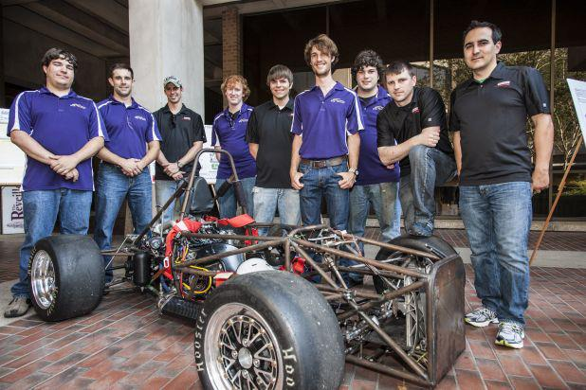
Sigma Lambda Chi

Electrical & Computer Engineering:
Institute of Electrical & Electronic Engineers (IEEE)
Eta Kappa Nu
Industrial Engineering:
Institute of Industrial Engineers (IIE)
Alpha Pi Mu
Mechanical Engineering:
American Society of Mechanical Engineers (ASME)
American Institute of Aeronautics & Astronautics (AIAA)
Society of Automotive Engineers (SAE)
Pi Tau Sigma
Petroleum Engineering:
Society of Petroleum Engineers (SPE)
American Association of Drilling Engineers (AADE)
Pi Epsilon Tau

AFTER ORIENTATION

- Complete Scheduling with Department Advisor and Staff.

- Use myLSU to select Registration Services to add Additional Services.

- Use myLSU to select Fee Bill to pay fees by semester deadline to complete registration (See the Registration Calendar on the University Registrar’s home page for deadline).

- Contact a counselor in UCFY (225-578-6822) or COE (225-578-5731) if you later earn AP/IB/CLEP or high school dual enrollment credits and need your schedule modified.

- Contact a counselor if you earn summer credits elsewhere and need to have your fall schedule modified.

- Submit an ALEKS qualifying score by the deadline if you intend TO REMAIN REGISTERED in Math 1550/1551 or contact a counselor if you fail to earn a passing score to modify your math placement.

How to sign up for ALEKS: Use your “myLSU” ID to log onto the “myLSU” page. Then navigate to the Student Services tab where you will find the "ALEKS Calculus Placement Test" link. Once logged in and redirected to the ALEKS Corporation, you will be required to submit a $25 payment via credit card. This fee gives you access to the initial assessment as well as the learning modules for a six-week period. For more information you may go to: http://www.math.lsu.edu.

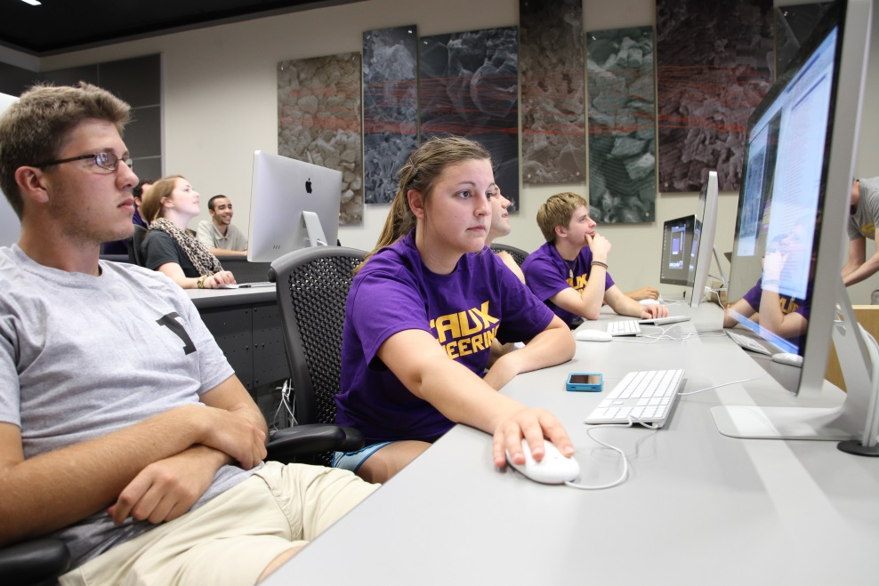

THE LSU ENGINEER
TODAY AND TOMORROW

A critical and holistic thinker and a life-long
learner with an entrepreneurial spirit.

Skilled communicator, adept at teamwork
and able to rally teams around him/her.

Great awareness of the national and global
implications of issues such as the environment
and sustainability --- always remaining
engaged with the community and society.

Hands-on problem solver, possessing a
strong work ethic and leadership qualities.

Well-grounded with sound technical
knowledge and understanding.

2228 Patrick F. Taylor, William Brookshire Student Services Suite ■ (225)578-5731 (p) ■ engr@lsu.edu ■ www.eng.lsu.edu

